THE ATTRIBUTE TABLES

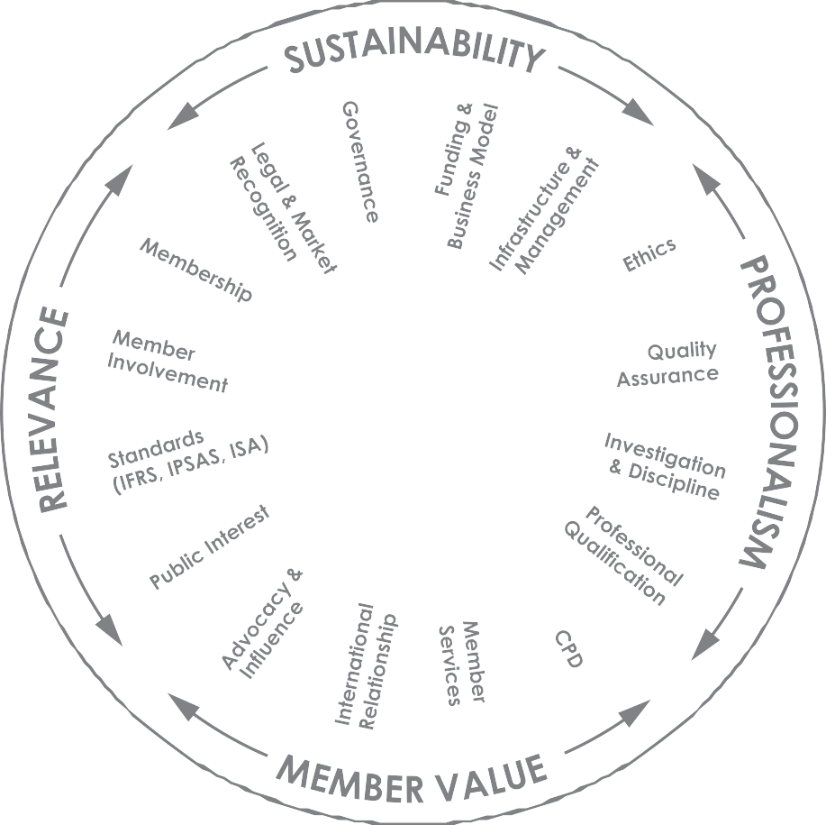

The attributes included in the Attribute Tables are
not necessarily exhaustive and should be viewed as examples

THE ATTRIBUTE TABLES

Legal & Market Recognition - Gaining a motive to establish, develop and maintain a PAO. The basis upon which the PAO exists and which establishes a clear mandate for it to operate.

Aspect | 1 | 2 | 3 | 4 | 5
Recognition by the public and by the private sector | No, or limited, recognition of the need for a PAO | Group formed by committed professionals to identify market needs | Actively working to meet market needs | PAO and professional accountants recognised by peer organisations and market stakeholders | PAO and professional accountants recognised by the public as fulfilling a key societal role
Recognition by government or regulatory authorities | No engagement with government or regulatory authorities | Limited engagement with government or regulatory authorities | Formal government recognition, which over time will lead to statutory recognition  Collaboration with government or regulatory authorities to develop regulation | Statutory recognition in legislation and/or charter  Established relationship with government or regulatory authorities | Planned, regular and effective liaison with government or regulatory authorities  Legislation protects and supports professional accountants in providing wide range of services
External oversight | None | None | Limited government oversight of licensing and regulations | Oversight of licensing and code of conduct for members | Comprehensive oversight of the profession in place, including external review  relating to governance, quality assurance (QA) and member licensing
Self-review | None | Governance structure and/or constitution without reference to external stakeholders | Governance structure or constitution established to support market needs | Strategic commitment to self-review and monitoring | Planned, regular and effective self-review and monitoring in place

Governance - Adhering to principles of good governance, including, where applicable, oversight mechanisms by which the PAO is directed, monitored and controlled.

Aspect | 1 | 2 | 3 | 4 | 5
Constitution or charter | No formal constitution or charter | Informal governance documentation | Established governance documentation, example , constitution, by-laws, policies and procedures | Effective and complete governance documentation | Comprehensive framework, including ongoing review and self-assessment
Leadership or corporate governance | No established leadership or governance structure | Voluntary leadership with limited corporate governance administration | Established council or board Key stakeholders involved  Leadership continuity and succession planning considered  Established and effective secretariat | Separation of governance and management roles and accountabilities | Clear understanding of the distinction between volunteer and secretariat roles  Effective review, performance monitoring and performance development in place  Independent, public members involved in boards and committees
Member involvement | No membership structure or involvement | Limited member involvement beyond voluntary leadership | Members involved in representation, with formal nomination, reappointment and election procedures  Members contribute to strategic development | Extensive committee structure with formal Terms of Reference | Board and committee performance review structure in place
Reporting | No annual reporting | Limited reporting, including financials | Formal reporting, including audited financial statements | Detailed financial and non-financial performance reporting | Formal audit and risk committee structure

THE ATTRIBUTE TABLES

Funding & Business Model - Establishing a viable, sustainable organisation able to achieve stated mission and objectives. Active attention to strategies and risks.

Aspect | 1 | 2 | 3 | 4 | 5
Strategic planning | No business model or strategic plan | Short-term and informal approach  Limited policy framework | Identified business objectives Strategic planning framework  Operational plan supported by effective management systems and controls  Consistency and continuity in strategic planning | Clearly articulated longer-term vision  Strategic plan implemented and monitored  Key risks identified and monitored  Strategy considers wide membership admission to maximise revenue streams | Comprehensive strategic planning and risk management  Performance monitored against strategy  Extensive Board input to strategic direction
Finance | Ad hoc | Limited budgeting, revenue generation and cost control | Clear understanding of business cycle, cash flow and revenue  Critical mass supporting sustainable revenue streams, in turn supporting minimum required resources  Effective cost controls Effective internal controls | Financially stable with:  - Capital expenditure plan  - Budget linked to performance indicators  - Management accounting subject to detailed and regular overview  - Internal audit | Active management of capital investment  Business model articulated and stress-tested  Active and independent audit committee

Infrastructure & Management - Establishing the foundations for maintaining high quality, effective operations, whether resources are volunteer or paid.

Aspect | 1  No formal structure | 2  Developing structure | 3  Established governance and management structure | 4  Fully resourced with experienced management | 5  Management has extensive experience, including strong knowledge of the accounting profession and of managing a membership body  Comprehensive management information strategy
Organisational structure | No formal structure | Developing structure | Established governance and management structure | Fully resourced with experienced management | Management has extensive experience, including strong knowledge of the accounting profession and of managing a membership body  Comprehensive management information strategy
Staff | Limited or no staff | Informal recruitment processes  Staff have limited management experience | Established business plan in place, with the necessary staff resources  Chief Executive Officer (CEO) in place | Empowered, non-volunteer CEO  Robust HR systems in place, example, payroll, health and safety, recruitment, staff development, performance management, equal opportunities | Comprehensive team engagement strategy including internal communications framework
Facilities and systems | Limited or none | Established physical base  Limited information, communications and technology (ICT) investment | Effective facilities and systems including ICT infrastructure and website in place  Member database meets  the needs of the organisation | Business support systems in place, example, performance indicators, business continuity, succession planning, insurance | Brand and Intellectual Property (IP) managed and protected  E-learning and e-commerce platforms  Sophisticated membership relationship and management systems

THE ATTRIBUTE TABLES

Membership - Generating a clear view of whom the organisation represents.

Aspect | 1 | 2 | 3 | 4 | 5
Framework | Informal membership or association. No register but may keep an attendance list | Basic membership categories and register | Differential membership categories and register | Membership allows for accountants working in all sectors of the economy | Comprehensive membership categories and register
Basis for Admission | No formal admission criteria  Informal application process  No fee | Limited requirements for admission  Link to academic programs Limited fees | Admission criteria includes education, examination and practical work experience  Membership fee | Array of educational pathways  Examination system includes wide range of elective subjects | Professional academic requirements embedded in undergraduate courses
Admission for members of other PAOs | Not considered | Ad hoc, inconsistent approach | Available to certain PAOs in specific, limited circumstances | Available to range of overseas qualified accountants via mutual recognition agreements | Comprehensive suite of mutual recognition agreements
Ongoing Membership Requirements14  Links to  Continuing Professional Development (CPD) | No requirements | CPD expected but not a requirement | CPD recognised as a requirement for ongoing membership  Payment of membership fee by set deadlines | CPD is monitored and declarations by members required annually | CPD is monitored and enforced

¹⁴ CPD is the most common ongoing membership requirement, however there may be others requiring an annual declaration.

Member Involvement - Working to capture the members’ needs, views and expertise to help meet the organisation’s objectives.

Aspect | 1 | 2 | 3 | 4 | 5
Involvement in governance | No member input in board or council governance  No committee structures | Limited member involvement or input in governance  Informal committee structure | Members involved in selection or appointment of directors or council members  Basic committee structure exists | Clear governance policies, including specified member involvement in governance  Committee structure exists covering all key governance activities | Well-developed and articulated governance policy  Comprehensive selection or nomination committee policy and process based on merit
Member consultation | No member consultation mechanisms | Informal consultation of members | Limited member consultation  Member input sought on strategic direction | Members regularly consulted on issues affecting the PAO or profession  Members actively involved in shaping strategic direction of the PAO | Well-developed and articulated member engagement policy  Comprehensive member involvement in all facets of the PAO  Detailed consultation mechanisms  Benchmarking of member involvement to best practice  Member committees, discussion groups and chapters actively provide input into member advocacy
Members representing PAO externally | No involvement of members in representation | Limited member involvement in representing PAO | Members engaged in representing PAO in general public forums and events | Members actively involved with specific stakeholders | Members actively involved in representing the PAO with wide range of key stakeholders

THE ATTRIBUTE TABLES

Standards (IFRS, IPSAS, ISAs)15 - Adoption and implementation16 of core international reporting and audit standards upon which the profession is based and upon which services are delivered by members to meet public and stakeholder needs.

Aspect | 1 | 2 | 3 | 4 | 5
Adoption and implementation of international standards | No objective or intention to develop, adopt or implement standards | Established objective to promote adoption and implementation of international standards | Adoption of international standards agreed and implementation plan in place | Adoption and implementation of international standards effected | Ongoing processes are in place to support adoption and implementation of international standards
Set, or contribute to, standard-setting (nationally or internationally)  Note: the specific involvement will depend on the responsibilities,  if any, the PAO has with respect to standard-setting | No authority to set standards or relationship with key stakeholders holding such authority | Initial relationship established with government to develop appropriate regulatory framework and standard- setting roles and authorities | Clear roles established with government, including authority for development of accounting and auditing standards | Works closely with regulators to develop and implement standards  Monitors and influences  standard-setter’s work programs  Engages in issues of applicability and practical challenges of implementation  Established as legitimate spokesperson on standards | Provides professional practice standards for the conduct of its members  Represents the needs of  the profession to international standard-setting organisations  Supports and influences standard-setter’s activities, programs and pronouncements  Regularly comments on international pronouncements
Guidance and education | No standards committee, staff or guidance available to members  Not recognised as spokesperson or technical expert on professional standards | Committee established to review international standards in light of economic, legal and political environment | Review process in place for adoption of international standards  Technical resources available to provide technical advice and guidance | Programs in place to train local practitioners on use of standards | Training and awareness programs in place to monitor ongoing application of standards
SMO compliance | Not active | Considering how to address the requirements of SMOs 3, 5 & 7 | Has a defined plan to address the requirements of SMOs 3, 5  & 7 | Executing and implementing the requirements of SMOs 3, 5  & 7 | Ongoing commitment to continuous improvement in addressing requirements of SMOs 3, 5 & 7

¹⁵ Adoption and implementation of international standards will vary from country to country, and may include transition from a country’s own developed standards and/or adoption of international standards.
¹⁶ Adoption is concerned with the decision that international standards are appropriate for use in specific national financial reporting environments and with the actions necessary to effect those decisions, including incorporation into national requirements or requiring the use of international standards through law. Adoption may include a process to review draft international standards, translation, public exposure of proposed standards, approval, incorporation into national requirements as necessary, and promulgation of final standards, and, where applicable, a convergence process to eliminate or minimise differences between international and national standards. Implementation may include a process to build awareness of the adopted standards, provide relevant education and training, develop or disseminate implementation guidance and any other activities that promote proper understanding and use of the standards in practice.

Public Interest17 - Building the appropriate culture and other factors that enable the organisation to act in the public interest.

Aspect | 1 | 2 | 3 | 4 | 5
Consideration of public interest by PAO | No consideration given to public interest in the organisation’s actions, decisions or policies | Limited consideration given to public interest in the organisation’s actions, decisions or policies  Appreciation of requirements and acknowledgement of stakeholder expectations | Consideration given to public interest in the organisation’s actions, decisions or policies | Advocates for consideration of the public interest in all matters  Consults public representatives in the organisation’s decisions, actions and policies | Involves public representatives in the organisation’s decisions, actions and policies  Maintains constructive dialogue with international organisations, governments, regulators, universities, and other finance industry stakeholders
PAO acts in the best interest of the public | Not specifically considered | Not specifically considered | Requirements promoted and taken into account informally or intuitively in decision- making processes | Advocate for adoption of high-quality international standards (education, ethics, etc.)  Specifies appropriate educational requirements and qualifications for members | Works with the regulatory community and governments  to develop and implement high- quality international standards  Where authority rests with the PAO, regulations are clearly established
Members required to act in the public interest  Links to Ethics and  Investigation & Discipline | No requirement | No requirement | High level of member awareness on the importance of the public interest | Members required to apply high standards of ethical behaviour and professional judgment | Member actions contrary to public interest are addressed

¹⁷ IFAC defines the public interest as the net benefits derived for, and procedural rigor employed on behalf of, all society in relation to any action, decision or policy. See IFAC Policy Position Paper #5 – A Definition of the Public Interest

THE ATTRIBUTE TABLES

Ethics18 - Establishing clear and appropriate standards of conduct.

Aspect | 1 | 2 | 3 | 4 | 5
Law and regulation | Few or no legal or regulatory requirements | Limited engagement with government or regulators | Clear legal or regulatory requirements in place | Systematic monitoring and review of legal or regulatory requirements | The “go to” body for government or regulators when reviewing requirements
Awareness | No understanding of ethical requirements as a core attribute of a PAO | Some engagement with members | Members and staff understand the requirements | Engages in debate, with comments valued by key influencers as authoritative and constructive | Widespread public awareness that members are required to behave ethically
Implementation and reporting | No reaction to problems  No commitment to developing and implementing ethical requirements | Plan of action under development | Buy-in by members to be compliant  Implementation plan aligned with investigation and discipline framework | Effective implementation that encourages acting in the broader public interest where appropriate  Discipline consistently applied and outcomes published | Recognised nationally and internationally as a role model  Advisory helplines and support schemes in place  Proactive and external review
Training | Few or no training opportunities | Training programme in development | Training programme in place | Training fully integrated into CPD programmes | High-quality training programme, regularly updated in the light of practical experience
SMO  compliance19 | Not active | Considering how to address the requirements of SMO 4 | Has a defined plan to address the requirements of SMO 4 | Executing and implementing the requirements of SMO 4 | Ongoing commitment to continuous improvement in addressing requirements of SMO 4

¹⁸ Ethical requirements apply to the staff as well as to the members of PAOs. PAOs should comply with good practice in the way they are managed, governed, and financed. Their members should similarly comply with good practice in whichever sector or jurisdiction they work. It is assumed that even where ethical standards and codes are set by government, regulators, or other appointed authorities, the PAO will have a role in encouraging compliance by its members.
¹⁹ SMO 4, International Ethics Standards Board for Accountants - Code of Ethics for Professional Accountants. Requires the adoption and implementation of the Code.

Quality Assurance (QA)20 - Establishing standards and systems to monitor the quality of services provided by members to the public.

Aspect | 1 | 2 | 3 | 4 | 5
Standards and guidance | None | Guidelines developed and issued | Minimum standards and requirements established at the levels of:  - audit engagement  - firm  - body responsible for quality assurance review | Guidance to members  Requirements in place across the full range of public accounting services | Regular review of standards and requirements Guidance to members regularly updated  Advice structures in place, for example, helplines
Implementation and monitoring | None | No formal monitoring of compliance | QA programme based on periodic review cycle  Necessary allocation of management resources | Dedicated management resources with necessary skills and competences  Risk-based review cycle  Transparent and documented policies and procedures | Regular review of QA programme to ensure compliance with external standards  QA committee with balanced and independent representation  Established cooperation with other oversight bodies or regulator
Reporting | None | None | Outcomes shared with members  Outcomes used to inform development of guidance and CPD | Annual public reporting  Outcomes embedded in CPD programmes  Implementation of disciplinary procedures where there is non- compliance | Outcomes shared with and feedback sought from external stakeholders  Mutual recognition programmes with other regulators
SMO  compliance | Not active | Considering how to address the  requirements of SMO 1 | Has a defined plan to address the requirements of SMO 1 | Executing and implementing the requirements of SMO 1 | Ongoing commitment to continuous improvement in addressing requirements of SMO 1

²⁰ SMO 1, Quality Assurance. Contains detailed requirements for the organisation and operation of quality assurance review systems.

THE ATTRIBUTE TABLES

Investigation & Discipline21 - Handling complaints about misconduct appropriately.

Aspect | 1 | 2 | 3 | 4 | 5
Awareness and framework | None | Some recognition by members that they should be accountable  Plan of action to introduce processes for dealing with complaints | Awareness by public and members of a documented complaints process  Necessary allocation of resources  Established investigation and discipline procedures in governance documents | Resources and expertise allocated to enable timely investigation and disciplinary action  Clear distinction between investigation, disciplinary and appeals functions | Public and member awareness of comprehensive and effective procedures, which are publicly reported
Implementation and reporting | None | Limited disciplinary processes, but without reporting | Member involvement  Reporting of outcomes to members | Formal nomination process for appointment to tribunals  Appeals process  Public reporting of outcomes  Members required to self-report disciplinary offences | Independent tribunals comprising appropriate professional and legal expertise  Detailed reporting  Independent review of cases not proceeding after investigation
SMO compliance | Not active | Considering how to address the requirements of SMO 6 | Has a defined plan to address the requirements of SMO 6 | Executing and implementing the requirements of SMO 6 | Ongoing commitment to continuous improvement in addressing requirements of SMO 6

²¹ SMO 6, Investigation and Discipline. Contains detailed requirements for the organisation and operation of investigation and disciplinary systems.

Professional Qualification (PQ)22 - Establishing the required competency benchmarks for professional or other qualifications.23

Aspect | 1 | 2 | 3 | 4 | 5
Policy & framework | No policy exists | PQ is linked to existing recognised education programs or overseas qualifications | Specific PQ established, largely technical-based, offering access to audit and practice | PQ is developed by the profession, meets market and academic requirements, is attractive to students  Examinations include elective options | PQ relies on a competency-based model of certification
Requirements  Education  Experience & development | None | PQ based on completion  of existing, possibly tertiary, education courses  No experience requirement | PQ based on completion of education courses influenced (design and/or content) by the PAO, or specifically designed standalone programs  Practical experience required, largely time-based rather than quality-based, but not monitored | PQ based on PAO-developed education programs, or assessed and approved tertiary education programs  Practical experience requirements specify nature and time commitments, and are monitored | Competency requirements used to direct development of tertiary and PAO education programs, and include technical and non technical matters, example, leadership, professionalism  Competencies assessed through examination and/or practical experience
Assessment of the qualification for both educational  and practice requirements | None | Little transparency  No external moderation; system open to abuse | Assessment integrated with curriculum and tuition: students, tutors and practice-experience supervisors understand what is expected; system security measures in place | Tuition providers, examiners and practice-experience supervisors subject to quality control; system is secure with low level of abuse | Transparent, robust, secure and trusted assessment, externally moderated and monitored, with  high level of stakeholder confidence, a model for other qualification providers
Resources and support | None | Limited | Reliance on third parties to deliver education programs  Students have access to curriculum supported by tuition and learning materials | PAO has the resources and experience to assess or develop programs, perhaps in partnership with third parties | PQ administered flexibly, including online capability  PQ subject to regular review and revision in consultation with wide range of stakeholders
SMO compliance | Not active | Considering how to address the requirements of SMO 2 | Has a defined plan to address the requirements of SMO 2 | Executing and implementing the requirements of SMO 2 | Ongoing commitment to continuous improvement in addressing requirements of SMO 2

²² SMO 2, International Education Standards (IESs) for Professional Accountants and other Pronouncements issued by the International Accounting Education Standards Board. A number of the IESs are applicable to PQ.
²³ While this table focuses on the professional accounting qualification, it is recognised that organisations may also administer other qualifications, such as for accounting technicians. In this situation, the other qualification can be substituted for the professional qualification (PQ) and the attributes equally applied, as appropriate.

THE ATTRIBUTE TABLES

Continuing Professional Development (CPD) - Maintaining and enhancing member competencies to enable delivery of high-quality

services to business, government and the public.

Aspect | 1 | 2 | 3 | 4 | 5
Policy | No CPD system | CPD is voluntary | CPD policy established Policy not monitored  Active promotion of CPD and its importance | Policy monitored | Policy monitored and non-compliance addressed via investigation and discipline
Staffing and oversight | Volunteer-led and sponsored | Limited staff focus | Specific staff focus | Dedicated staff established  CPD committee involvement | Comprehensive reporting to board or council
Programs and delivery | Limited and ad hoc training courses  Volunteer trainers | Informal planning and delivery of training program  Program influenced by supply and not demand  Training materials accessed from other PAOs  Quality of training inconsistent and not measured  Courses generally provided for free or nominal amount | Reasonable training program established  Links established with universities and other training suppliers  Some regular, competent presenters identified  Course fees generally charged | Comprehensive training program  Pool of competent trainers identified | Dynamic program: topics regularly evaluated and prioritised  Trainer accreditation requirements implemented  Online CPD to support extensive program  Learning outcomes verified and measured
SMO  compliance24 | Not active | Considering how to address the requirements of SMO 2 | Has a defined plan to address the requirements of SMO 2 | Executing and implementing the requirements of SMO 2 | Ongoing commitment to continuous improvement in addressing requirements of SMO 2

²⁴ SMO 2, International Education Standards (IESs) for Professional Accountants and other Pronouncements issued by the International Accounting Education Standards Board. CPD is addressed in IES 7.

Member Services - Satisfying the needs of members with highly valued services.

Aspect | 1 | 2 | 3 | 4 | 5
Vision | No vision or strategy | Limited vision or strategy | Established vision, but inconsistent buy-in | Unified vision for member services | Member-service focused culture, with ongoing investment and improvement
Approach | No specific activities or resources applied to understanding member needs | Annual member satisfaction survey  Reactive approach Limited staff focus | Proactive approach in some areas  Dedicated member- service staff | Consistent and integrated approach  Member-experience metrics feeding top-level goals | Satisfaction surveys; complaint procedures; suggestion schemes  Core “member experience” team established and advising on strategies
Services provided | No networking events  No tools, resources, or technical assistance  No library  No newsletter | Annual conference or networking event  Very limited technical assistance  Occasional newsletter Fairly static website | Library facilities  Several conferences or networking events  Limited technical assistance, for example, email and hotline  Regular newsletter  Functional website regularly maintained | Specialised, targeted conferences program  Technical assistance department  Newsletters targeted to specific member groups  Member-focused discounts or loyalty programs | Web events, CPD and conferences  Career resources (from student to executive)  Resource-rich research, guidance and other materials  Online library  Full technical assistance, including technical hotline  Multiple contact channels with high use of technology: email, web, magazine, podcast, etc.  Extended loyalty programs (for example, branded credit cards)  Non-technical support services, for example, counselling, mentoring, business and personal development

THE ATTRIBUTE TABLES

International Relationships - Collaborating with others in the interest of advancing the successful development of the organisation, including accessing educational programs, CPD and other resources.

Aspect | 1 | 2 | 3 | 4 | 5
Resources | No particular focus | Reliance on specific individuals working in ad hoc manner | Staff with defined international-relations role | Staff with dedicated international-relations role | Dedicated international-relations function  Involvement of experts, advisors and/or established committee  Secondment of staff to other professional organisations
Scope or Activities | No, or minimal, communication and collaboration with others | Aware of the importance of collaborating with others; seeks some relationships | Limited international objectives or goals established | International objectives and goals implemented and monitored | Comprehensive international strategy established  Mentoring provided to developing PAOs
Outcomes | No established relationship with any accounting groups | Member of accounting  groups or regional accounting organisations, but no involvement in activities | Member of regional and/or international accounting organisations, with limited involvement  Links established with limited number of other PAOs | Active participation in regional and/or international accounting organisations  Partnering with PAOs established | Strong influence in regional and/or international accounting organisations and their key  sub-committees  Recognised by broad range of international “institutional” organisations

Advocacy & Influence25 - Developing the means by which the PAO effects change to meet the needs of members, stakeholders and the public.

Aspect | 1 | 2 | 3 | 4 | 5
Resources | No resources to engage in debates | Volunteer-led resources | Resources established to monitor issues | Dedicated staff resources and capability for research | Dedicated staff resources  Deep cadre of spokespersons established
Scope or Activities | Little or no activity | Ad hoc monitoring of issues affecting the profession  Comment sporadic and reactive | Key relationships established with key influencers and relevant stakeholders, including universities  Comment limited to particular topics | Comprehensive, systematic monitoring of issues  Comment takes account of the broader public interest as well as the narrower interests of members  Effective media management | The “go to” body for government, regulatory authorities and think tanks  Engages in wide range of economic, business, and social matters
Outcomes | Not recognised | Key influencers pay little attention  Not seen as adding value to the debate | Comment valued by key influencers  Recognised as a legitimate commentator | Comment issued early enough to influence outcomes  Comment valued by key influencers as authoritative and constructive  Regarded highly by the business community | Value recognised by regional and global influencers as well as at a national level  Recognised as:  - significant player in shaping societal debates and policies  - speaking in the public interest  - thought leader

²⁵ Advocacy and influence work is aimed at a range of key influencers in business, government and regulatory authorities. The aspirations of individual PAOs will be affected by the nature of their relationship with government, which varies from jurisdiction to jurisdiction. Some PAOs are independent of government, some are part of government, and some have a dual role that entails fulfilling regulatory responsibilities on behalf of government as well as operating as an independent membership organisation.
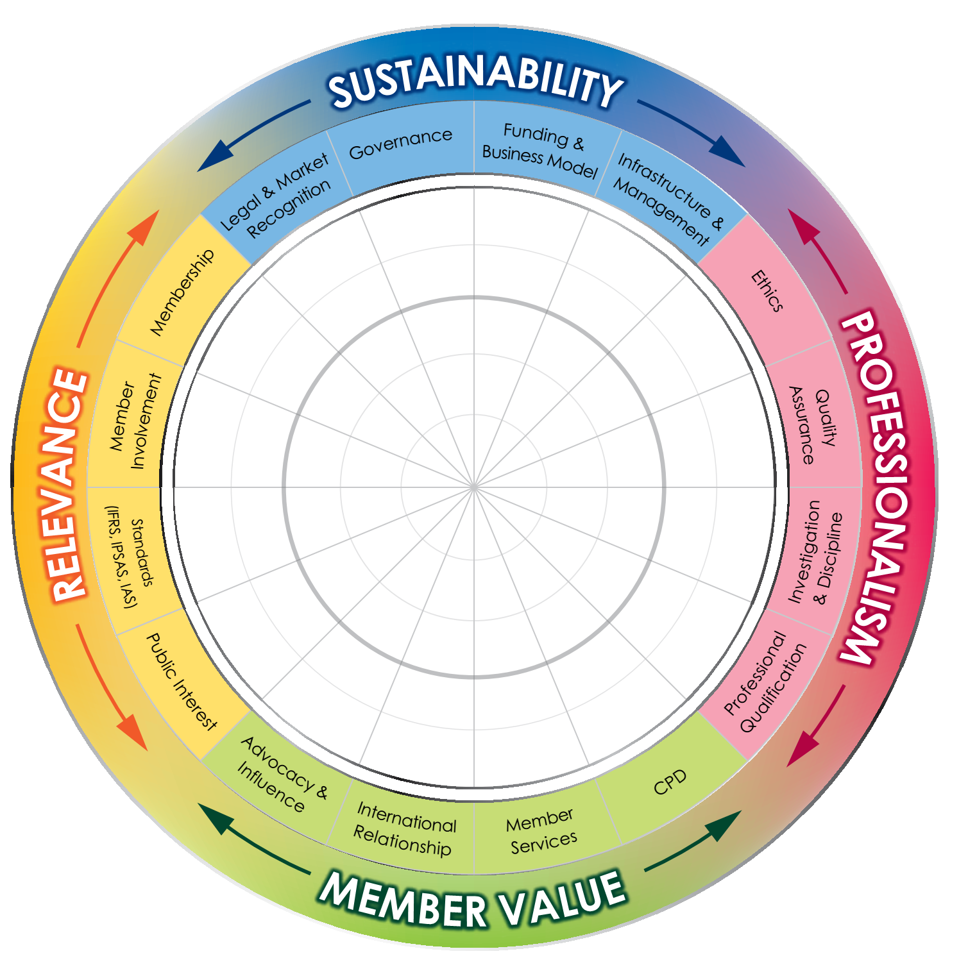
EXHIBIT 2: THE MATURITY MODEL – SELF-ASSESSMENT

